Image | 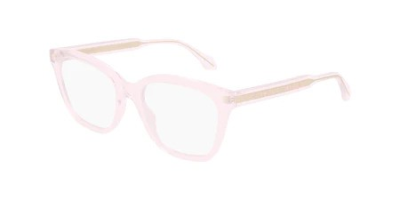
Brand | GUCCI
Model Name | GG 0566ON
Price | RS 2499
PRODUCT DETAILS

